- B
- D
- OMIT
- OMIT
- OMIT
- OMIT
- OMIT
- There are 13 spades in a deck
There 4 7’s in the deck
One four is covered in spade, so the outcomes are 3
Total outcomes = 13+ (4-1) = 15
Probability = 16/52 (F)
- With 52 cards in the deck,
13 are diamonds
3 of those are the jacks of clubs, spades and hearts (i.e. - the jacks we haven't already counted in the 13 diamonds above.)
This means there are 16 cards that are jacks or diamonds or both.
52 – 16 = 36 cards (not jacks or diamonds)
The probability of drawing one is 16/52
= 16/52 (F)
- The probability of drawing a 10 = 4/52
That of drawing a club is 13/52
And to draw a 10 given it is a club,
= 1/52 * 52/13
= 1/13 (F)
- 4 10s are found in a desk
4 kings are found in a deck also
P (10) = 4/52
P (King) = 4/52
P (10 and king)
= 4/52 * 4/52
= 1/169 (K)
- 4 10s are found in a desk
4 kings are found in a deck also
P (10) = 4/52
P (King) = 4/52
P (10 or king) = 4/52 + 4/52
= 8/52 (D)
- 1/9 *10/5
= 10/45
= 2/9 (C)
- 1/10 * 0/9
= 0/90
= 0 (H)
- OMIT
- 5C2
= 10 ways (B)
- Using the z-table, look up for the corresponding values
Pr (Z = 0.35)
= 0.6368 (D)
- Pr (Z > 0.35)
Pr (Z > 0.35) = 1 – P (Z > 0.35)
= 1 - 0.6368
= 0.363 (E)
- Pr (0 <=Z < 0.35)
Pr (Z >= 0.35) = 0.6368
Pr (Z <=0) = 0.5
=0.6368 - 0.5
= 0.1368 (G)
- Pr (Z > - 1.21)
= Read direct from the z-score table
= Pr (Z > - 1.21) = Pr (Z < 1.21)
= 0.8869 (B)

- Pr (Z <= - 1.21)
Pr (Z <= - 1.21) = 1 - Pr (Z <= - 1.21)
= 1 – 0.8869
= 0.1131 (G)
Part II
Q. 20.
A.
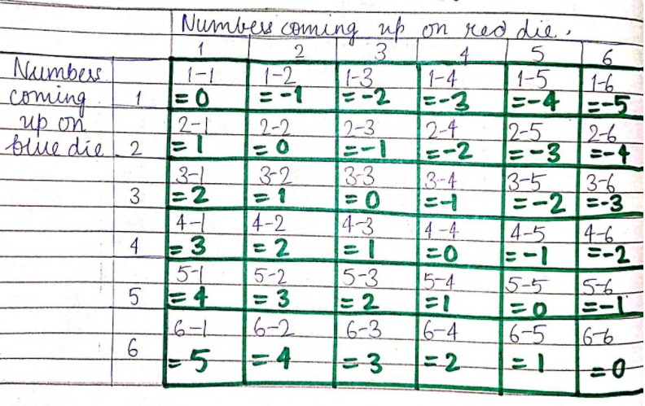
B. From the above table, the number of times the result is negative 3 = 3 times
Total results = 36
Probability = No. of times of result -3 / Total no. of results
Pr (-3) = 3 / 36
= 1/12
C. No. of times the result is 1 = 5
Total no. results = 36
Pr (1) = 5/36
= 5/36
D. P {x | x ≥ 0}
Number of times the results is zero or a number greater than zero:
P(0) = 6/36
P (1) = 5/36
Pr (2) = 4/36
Pr (3) = 3/36
Pr (4) = 2/36
Pr (5) = 1/36
Total = (6+5+4+3+2+1)/36
= 21/36
= 7/12
Question 21
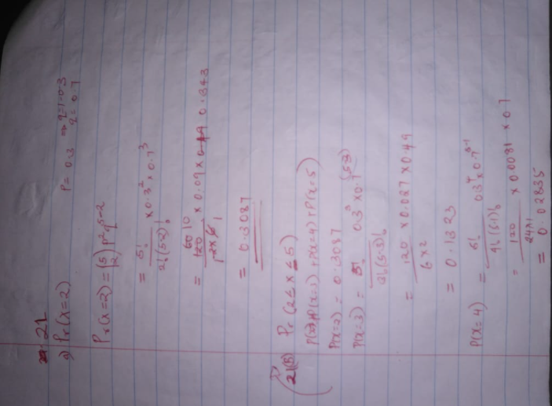

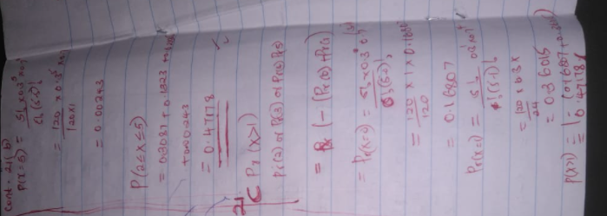

- OMIT

